Institution's Innovation Council Saurashtra University

Session on

Achieving Problem-Solution Fit & Product-Market Fit
27th December 2022
At
Department of Business Management Saurashtra University Campus, Rajkot

Contents

Saurashtra University – IIC 3
Event Schedule 3
Brief about the Event 4
Key Points 4
Outcome 4
About the Speaker/Chief Guest 5
Connect with us: 7

Saurashtra University – IIC
The university is dedicated to instruction, research, and extending knowledge to the public (public service). Ministry of Education (MoE), Govt. of India has established ‘MoE’s Innovation Cell (MIC)’ to systematically foster the culture of Innovation among all Higher Education Institutions (HEIs). The primary mandate of MIC is to encourage, inspire and nurture young students by supporting them to work with new ideas and transform them into prototypes while they are informative years. Saurashtra University is one the Organization that have constituted the IIC to foster the vision of MoE and be a part for the promotion and development of innovation ecosystem.

Event Schedule

13:00 | Welcome
13:20 | Awareness Session
15:00 | Q n A
15:20 | Closing Ceremony

Brief about the Event

Saurashtra University - Institutions' Innovation Council and SU Start-up and Entrepreneurship Council, collaboratively organized a session on ‘Achieving Problem-Solution Fit & Product-Market Fit’. The objective was to give participants knowledge about Problem-Solution Fit & Product-Market Fit.

Problem-Solution Fit & Product-Market Fit are the key factors behind the success of any start up. Most of the startups fail because they have created a product which has no market need. Problem Solution Fit is about understanding the market and identifying the actual problems need to be solved while Product-Market Fit is about transforming the solution into a product which will fit into the market and there will be enough number of customers buying the product as well as talking about the product.

Key Points

Key points discussed during the seminar were:
- Concept of Problem-Solution Fit
- Concept of Product-Market Fit
- Difference between Problem-Solution Fit & Product-Market Fit
- Importance of Problem-Solution Fit & Product-Market Fit for startups
- Product life cycle
- Product-Market Fit Pyramid
- FAQs related to Problem-Solution Fit & Product-Market Fit

Outcome

The students were made familiar with the concepts of Problem-Solution Fit & Product-Market Fit. The importance of Problem-Solution Fit & Product-Market Fit for startups were made clear by the speaker in the session. Differences between Problem-Solution Fit & Product-Market Fit were elucidated by the speaker. Product life cycle as well as Product – Market fit Pyramid were explained. Reasons for startup failure were also explained in the session.

About the Speaker/Chief Guest

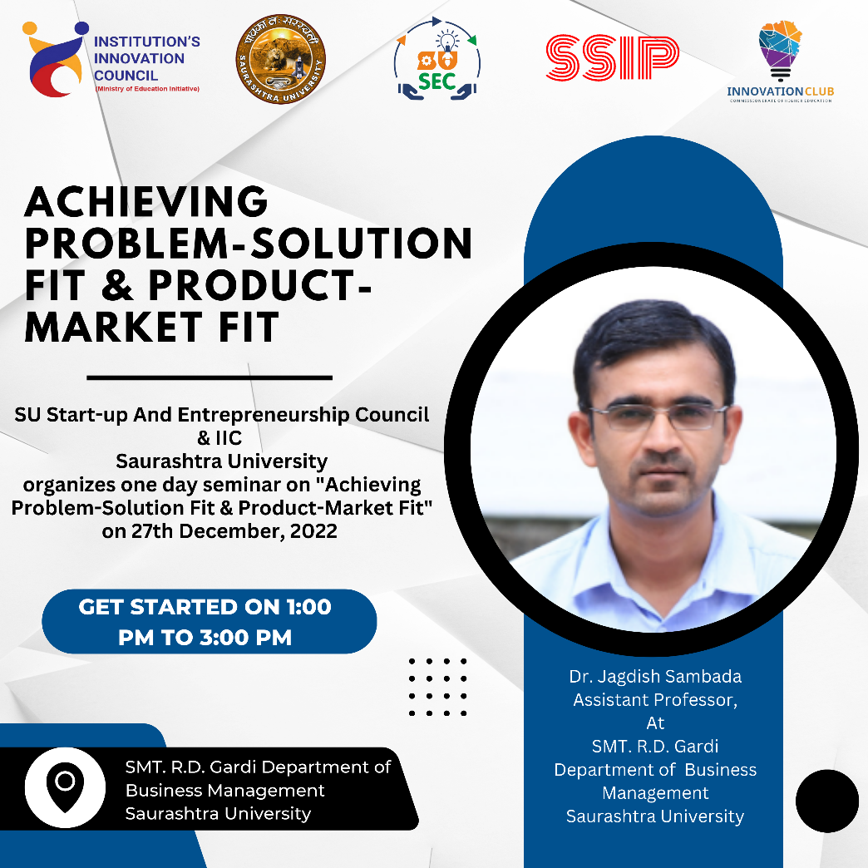

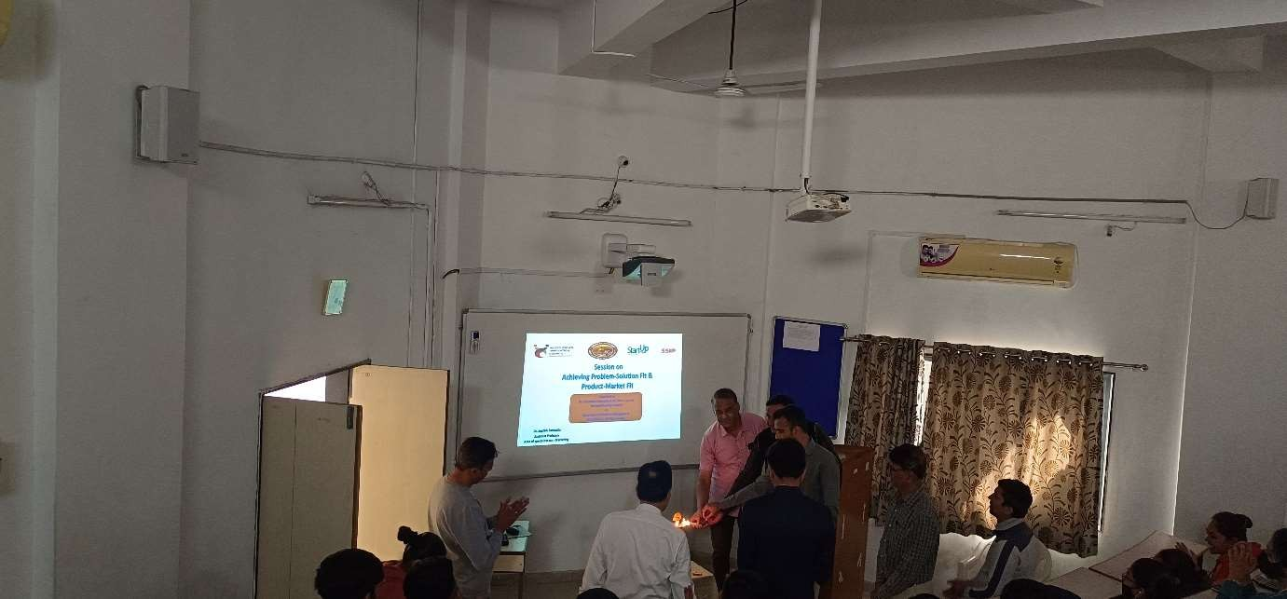

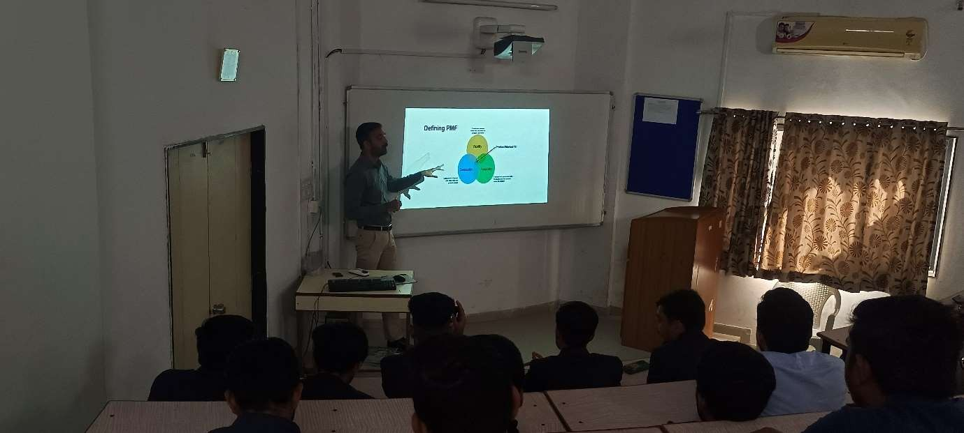

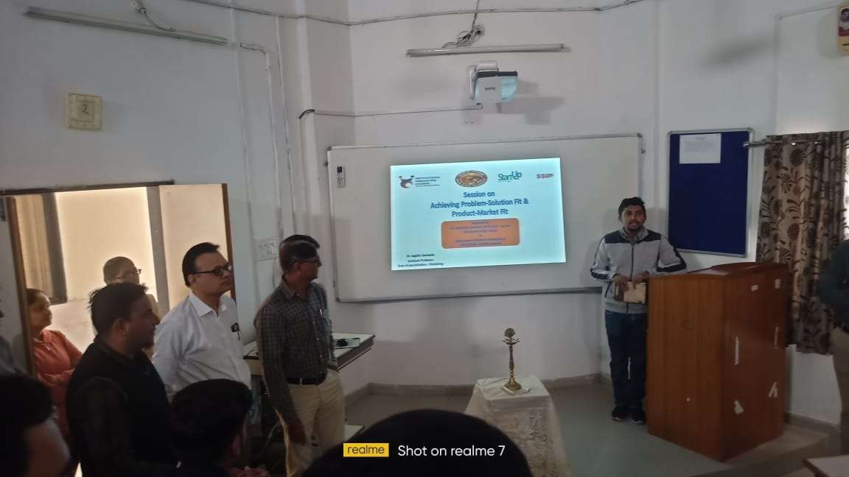

Connect with us:

https://www.linkedin.com/company/susec

iic@sauuni.ac.in
https://www.facebook.com/iicsauuni bit.ly/SU-SSIP Location
https://www.instagram.com/susecrajkot https://bit.ly/SUSEC-youtube

